**Villanueva, Jude Ryan D. BSIT III C**

**Engaging Activities**

A. Make a simple Web Application using Flask that successfully displays

the value of the inputted data from the HTML form and send the raw

data to the URL.

Data to be inputted:

1. Your name

2. A fixed word “is”

3. Your characteristic

B. Do some coding trials based on your curiosity in this lesson and make at

least 3-5 screenshots as a proof of your work discoveries.

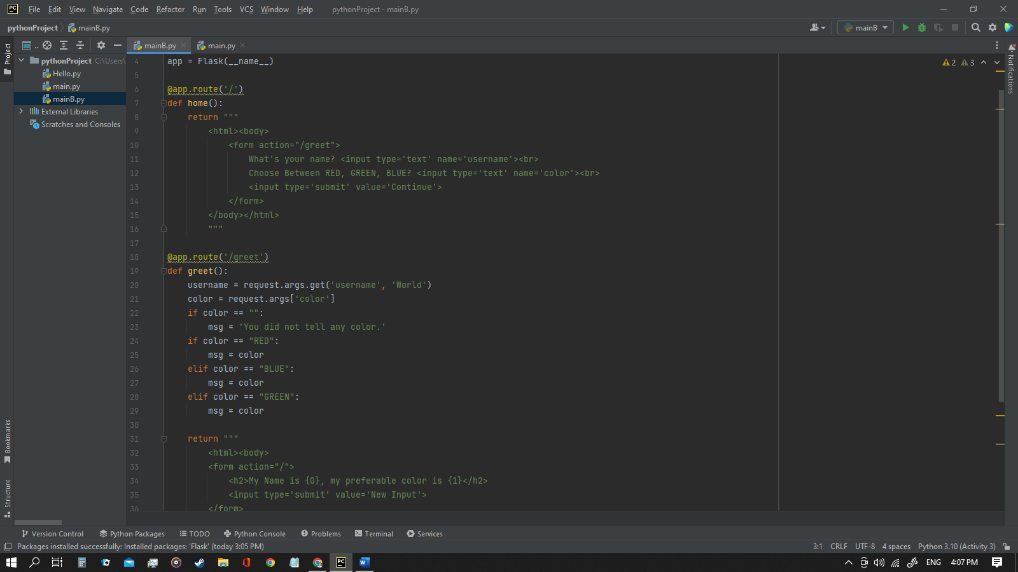

**PT 1**

**Directions:** Identify what are the words describes in the given meaning or sentences below:

**Informational Response** 1. The message consists only of the status line and optional header fields and is terminated by an empty line.

**HTTP Request Method** 2. When these requests are being sent, clients can use various methods.

**On the fly** 3. In Web Development, what does this symbol (?) means?

**URL** 4. It has three sections: the protocol, the server where the document is located, and the path to the requested resource on the server.

**CONNECT** 5. Used by the client to create a network connection to a web server over a particular

HTTP.

**PT 2**

**Directions**: Answer the Guided Questions on this module.

1. How can I develop a Web Application using Python Programming

Language?

Python is frequently used to create a website's or application's back end. The portions that users don't see. Sending data to and from servers, processing data and interacting with databases, URL routing, and maintaining security are all possible uses of Python in web development.

2. How does the Web Application works?

Through the application's user interface, the user sends a request to the web server across the Internet. The web application server receives this request from the web server. The web application server completes the specified operation and then produces the necessary data results.

3. Are there anything to be consider to create a Web Application using

Python Programming Language?

Python has several key advantages for web development, which is why it's become so popular in the computer world. You may scale a project quite quickly because to the language's flexibility in terms of multiple techniques and the abundance of libraries filled with pre-written code.